**[03-SelectionStructuresinPython](https://www.rajalakshmicolleges.net/moodle/course/view.php?id=84&section-3)**

**Ex.No. : 3.1 Date:**

**RegisterNo.: 231501070 Name:Kaaleeswaran v**

## [AdmissionEligibility](https://www.rajalakshmicolleges.net/moodle/mod/quiz/view.php?id=5706)

Writeaprogramtofindtheeligibilityofadmissionforaprofessionalcoursebasedonthefollowingcriteria:

MarksinMaths>=65MarksinPhysics>=55MarksinChemistry>=50Or

Totalinallthreesubjects>=180SampleTestCases

TestCase1Input

70

60

80

Output

ThecandidateiseligibleTestCase2

Input50

80

80

Output

ThecandidateiseligibleTestCase3

Input50

60

40

Output

Thecandidateisnoteligible

**Forexample:**

|  |  |
| --- | --- |
| **Input** | **Result** |
| 50  80  80 | Thecandidateiseligible |

# Program:

a=int(input())b=int(input())c=int(input())

if(a>=65 and b>=55 and c>=50):print("Thecandidateiseligible")

elif(a+b+c>=180):

print("Thecandidateiseligible")else:

print("Thecandidateisnoteligible")

# Output:

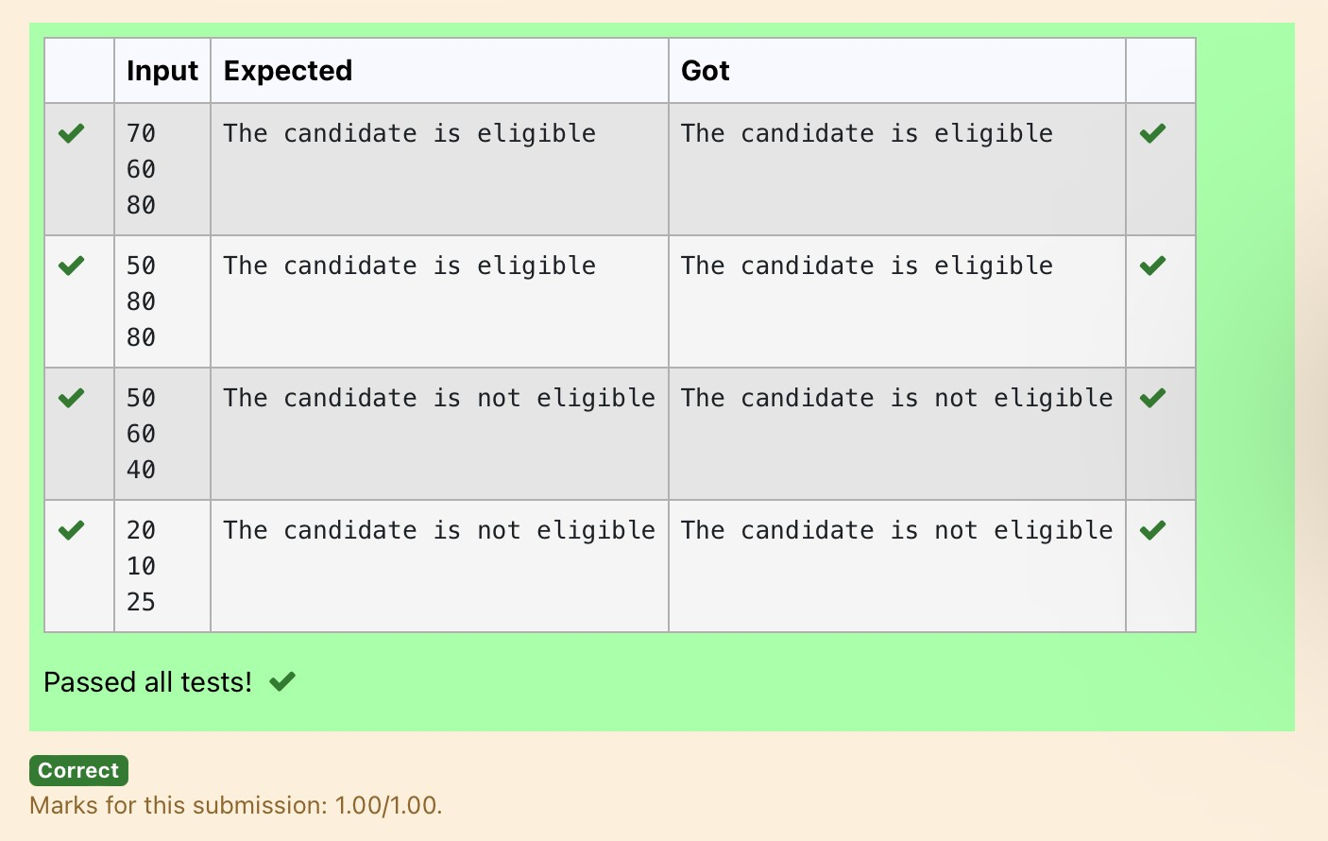

**Ex.No. : 3.2 Date:**

**RegisterNo.: Name:**

## [ClassifyingTriangles](https://www.rajalakshmicolleges.net/moodle/mod/quiz/view.php?id=5707)

A triangle can be classified based on the lengths of its sides as equilateral, isoscelesor scalene.Allthreesidesofanequilateraltrianglehavethesamelength.Anisosceles triangle has two sides that are the same length, and a third side that is adifferentlength.Ifallof thesideshavedifferentlengthsthen the triangle is scalene.

Write a program that reads the lengths of the three sides of a triangle from the user.Thendisplayamessagethatstatesthetriangle’stype.

SampleInput1

60

60

60

SampleOutput1

That'saequilateraltriangle

**Forexample:**

|  |  |
| --- | --- |
| **Input** | **Result** |
| 40  40  80 | That'saisoscelestriangle |

Program:a=int(input())b=int(input())

c=int(input())if(a==bandb==c):

print("That'saequilateraltriangle")elif(a!=bandb==cora==bandb!=c):

print("That'saisoscelestriangle")elif(a!=bandb!=c):

print("That'sascalenetriangle")

# Output:

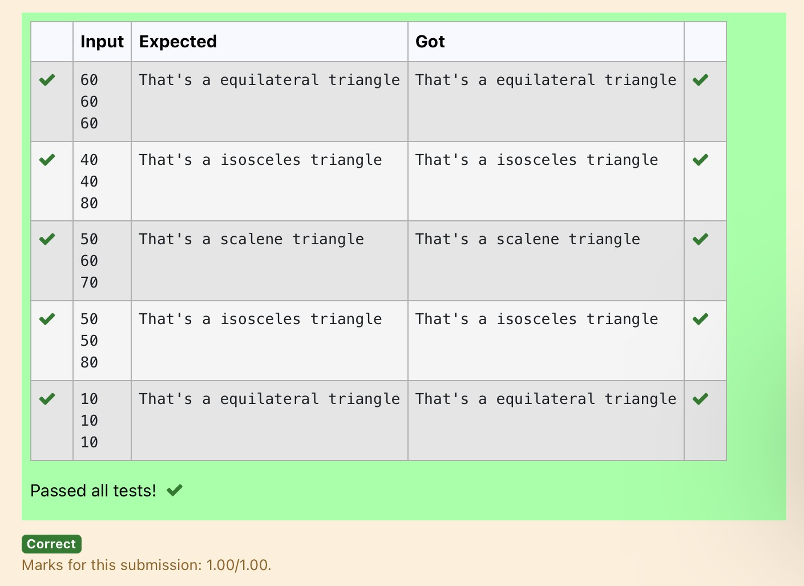

**Ex.No. : 3.3 Date:**

**RegisterNo.: Name:**

## [ElectricityBill](https://www.rajalakshmicolleges.net/moodle/mod/quiz/view.php?id=5708)

WriteaprogramtocalculateandprinttheElectricitybillwheretheunitconsumedby the user is given from test case. It prints the total amount the customer has topay.Thechargeareasfollows:

Unit Charge/Unit

Upto199 @1.20

200 and above but less than 400 @1.50400 and above but less than 600 @1.80600andabove @2.00

IfbillexceedsRs.400thenasurchargeof15%willbechargedandtheminimumbillshouldbeofRs.100/-

SampleTestCasesTestCase1

Input50

Output100.00

TestCase2Input

300

Output517.50

**Forexample:**

|  |  |
| --- | --- |
| **Input** | **Result** |
| 500 | 1035.00 |

# Program:

a=float(input())b=0

if(a<=199):

b=a*1.2elif(200<=a<400):

b=a*1.5elif(400<=a<600):

b=a*1.8elif(a>600):

b=a*2.0

if(int(b)<100):print("{:.2f}".format(100))

else:

if(b>400.00):

print("{:.2f}".format((b+(b*0.15))))else:

print("{:.2f}".format(b))

# Output:

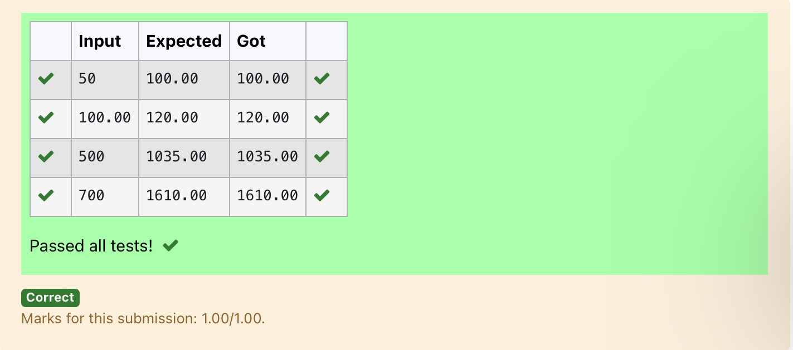

**Ex.No. : 3.4 Date:**

**RegisterNo.: Name:**

## [IN/OUT](https://www.rajalakshmicolleges.net/moodle/mod/quiz/view.php?id=5709)

Ms.Sita,thefacultyhandlingprogramming labforyou is very strict. Your seniorshavetoldyou thatshewillnotallowyoutoentertheweek'slabifyouhavenotcompleted atleast half the number of problems given last week. Many of you didn'tunderstand this statement and so they requested the good programmers from yourbatch to write a program to find whether a student will be allowed into a week's labgiven the number of problems given last week and the number of problems solved bythestudentinthatweek.

InputFormat:

Inputconsistsof2integers.

Thefirstintegercorrespondstothenumberofproblemsgivenandthesecondintegercorrespondstothenumberofproblemssolved.

OutputFormat:

Outputconsistsofthestring“IN”or“OUT”.SampleInputandOutput:

Input8

3

OutputOUT

**Forexample:**

|  |  |
| --- | --- |
| **Input** | **Result** |
| 8  3 | OUT |

# Program:

a=int(input())b=int(input())c=(a/2) if(c>b):

print("OUT")else:

print("IN")

# Output:

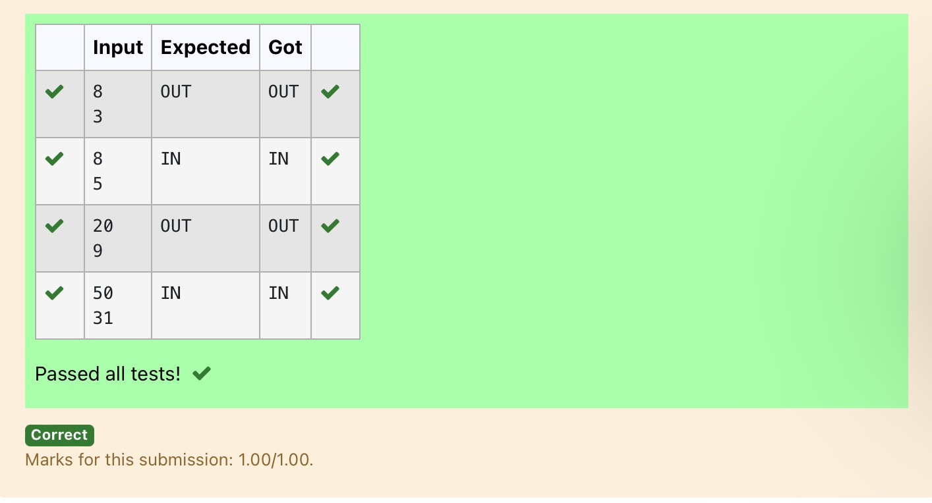

**Ex.No. : 3.5 Date:**

**RegisterNo.: Name:**

## [VowelorConsonant](https://www.rajalakshmicolleges.net/moodle/mod/quiz/view.php?id=5710)

Inthisexerciseyouwillcreateaprogramthatreadsaletterofthealphabetfromthe user.Iftheuserentersa,e,i,ooruthenyourprogramshoulddisplay amessage indicating that the entered letter is a vowel. If the user enters 'y' then yourprogram shoulddisplayamessageindicatingthatsometimesyis avowel,andsometimes y is a consonant. Otherwise your program should display a messageindicatingthattheletterisaconsonant.

Sample Input 1i

SampleOutput1It'savowel.

SampleInput2y

SampleOutput2

Sometimesit'savowel...Sometimesit'saconsonant.

Sample Input3c

SampleOutput3It'saconsonant.

**Forexample:**

|  |  |
| --- | --- |
| **Input** | **Result** |
| y | Sometimesit'savowel...Sometimesit'saconsonant. |
| u | It'savowel. |
| p | It'saconsonant. |

# Program:

a=input()

if(a=='a'ora=='e'ora=='i'ora=='o'ora=='u'):print("It'savowel.")

elif(a=='y'):

print("Sometimesit'savowel...Sometimesit'saconsonant.")

else:

print("It'saconsonant.")

# Output:

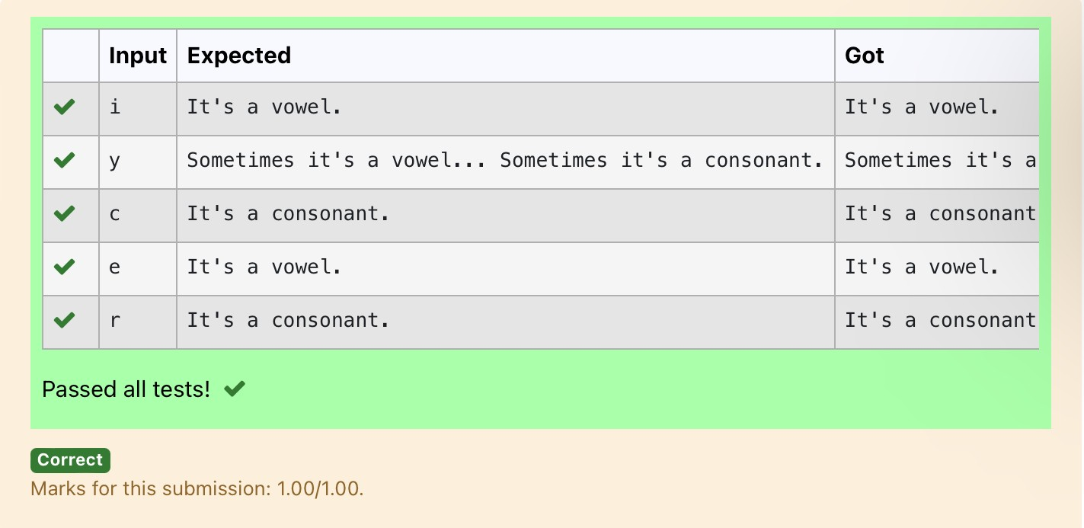

**Ex.No. : 3.6 Date:**

**RegisterNo.: Name:**

## [LeapYear](https://www.rajalakshmicolleges.net/moodle/mod/quiz/view.php?id=5711)

Most years have 365 days. However, the time required for the Earth to orbit the Sun isactually slightly more than that. As a result, an [extra](https://www.rajalakshmicolleges.net/moodle/mod/quiz/view.php?id=5753) day, February 29, is included insomeyearstocorrectforthisdifference.Suchyearsarereferredtoasleapyears.Therules fordeterminingwhetherornotayear isaleapyearfollow:

* Any yearthatisdivisible by400isaleapyear.
* Of the remainingyears,anyyearthatis divisible by100isnotaleapyear.
* Oftheremainingyears,anyyearthatisdivisibleby4isaleapyear.
* Allotheryearsarenotleap years.

Writeaprogramthatreadsayearfromtheuseranddisplaysamessageindicatingwhetherornotitisaleapyear.

SampleInput1

1900

SampleOutput1

1900isnotaleapyear.

SampleInput2

2000

SampleOutput22000isaleapyear.

# Program:

year=int(input())if(year%400==0):

print(year,"isaleapyear.")else:

print(year,"isnotaleapyear.")

# Output:

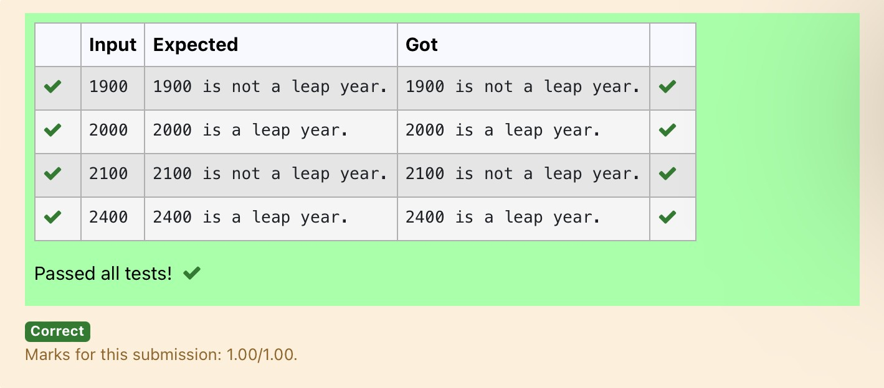

**Ex.No. : 3.7 Date:**

**RegisterNo.: Name:**

## [Monthnametodays](https://www.rajalakshmicolleges.net/moodle/mod/quiz/view.php?id=5712)

The length of a month varies from 28 to 31 days. In this exercise you will create aprogram that reads the name of a month from the user as a string. Then your programshould display the number of days in that month. Display “28 or 29 days” for Februarysothatleapyearsareaddressed.

SampleInput1FebruarySampleOutput1

Februaryhas28 or29daysinit.SampleInput2

March

Sample Output 2Marchhas31daysinit.SampleInput3

April

Sample Output 3Aprilhas30daysinit.**Forexample:**

|  |  |
| --- | --- |
| **Input** | **Result** |
| February | Februaryhas28or29daysinit. |
| March | Marchhas31daysinit. |

# Program:

m=input()if(m=="January"):

print(m,"has31daysinit.")elif(m=="February"):

print(m,"has28or29daysinit.")elif(m=="March"):

print(m,"has31daysinit.")elif(m=="April"):

print(m,"has30daysinit.")elif(m=="May"):

print(m,"has31daysinit.")elif(m=="June"):

print(m,"has30daysinit.")elif(m=="July"):

print(m,"has31daysinit.")elif(m=="August"):

print(m,"has31daysinit.")elif(m=="September"):

print(m,"has30daysinit.")elif(m=="October"):

print(m,"has31daysinit.")

elif(m=="November"):print(m,"has30daysinit.")

elif(m=="December"):print(m,"has31daysinit.")

# Output:

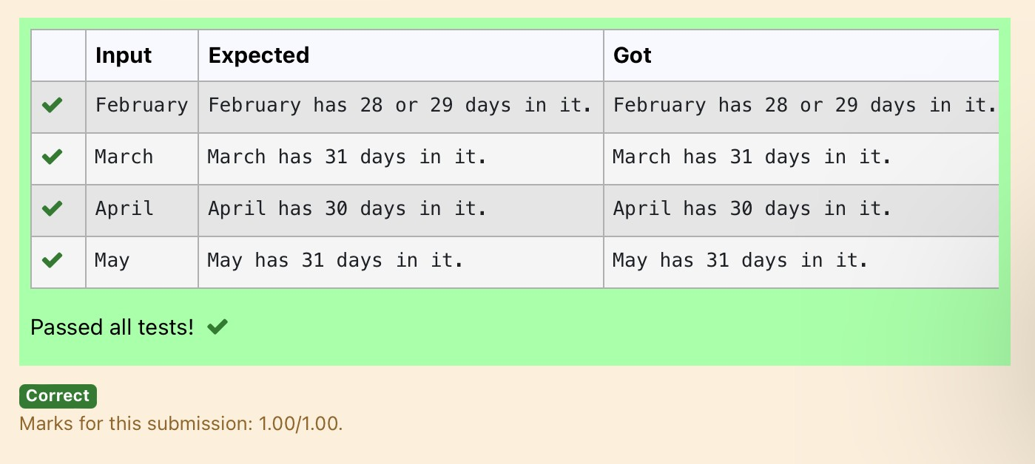

**Ex.No. : 3.8 Date:**

**RegisterNo.: Name:**

## [Pythagoreantriple](https://www.rajalakshmicolleges.net/moodle/mod/quiz/view.php?id=5713)

Three numbers form a Pythagorean triple if the [sum of squares](https://www.rajalakshmicolleges.net/moodle/mod/quiz/view.php?id=5759) of two numbers isequaltothesquareofthethird.

For example, 3, 5and4form a Pythagorean triple, since 3*3 + 4*4 = 25 = 5*5You are given three integers, a, b, and c. They need not be given in increasing order.IftheyformaPythagoreantriple, thenprint"Yes",otherwise,print"No".

**SampleInput**

3

5

4

**SampleOutput**

Yes

**Forexample:**

|  |  |
| --- | --- |
| **Input** | **Result** |
| 3  4  5 | Yes |

# Program:

a=int(input())b=int(input())c=int(input())if(a*a+b*b==c*c):

print("yes")

elif(a*a+c*c==b*b):print("yes")

elif(c*c+b*b==a*a):print("yes")

else:

print("no")

# Output:

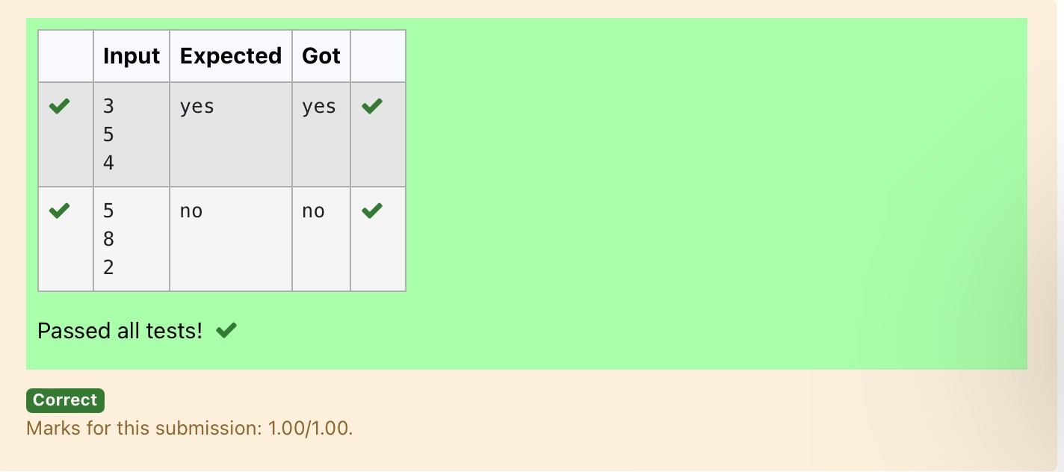

**Ex.No. : 3.9 Date:**

**RegisterNo.: Name:**

## [Secondlastdigit](https://www.rajalakshmicolleges.net/moodle/mod/quiz/view.php?id=5714)

Write a program that returns the second last digit of the given number. Second lastdigitisbeingreferred10thedigitin thetensplacein thegivennumber.

Forexample,ifthegivennumberis197,thesecondlast digit is9.

Note1-Thesecondlastdigitshouldbereturnedasapositivenumber.i.e.ifthegivennumberis-197,thesecondlastdigitis9.

Note2 - If the given number is a single digit number, then the second last digit doesnot exist. In such cases, the program should return -1. i.e. if the given number is 5,thesecondlastdigitshouldbereturnedas-1.

**Forexample:**

|  |  |
| --- | --- |
| **Input** | **Result** |
| 197 | 9 |

# Program:

a=int(input())b=str(abs(a))l=len(b)if(l>1):

print(int(b[-2]))else:

print(-1)

# Output:

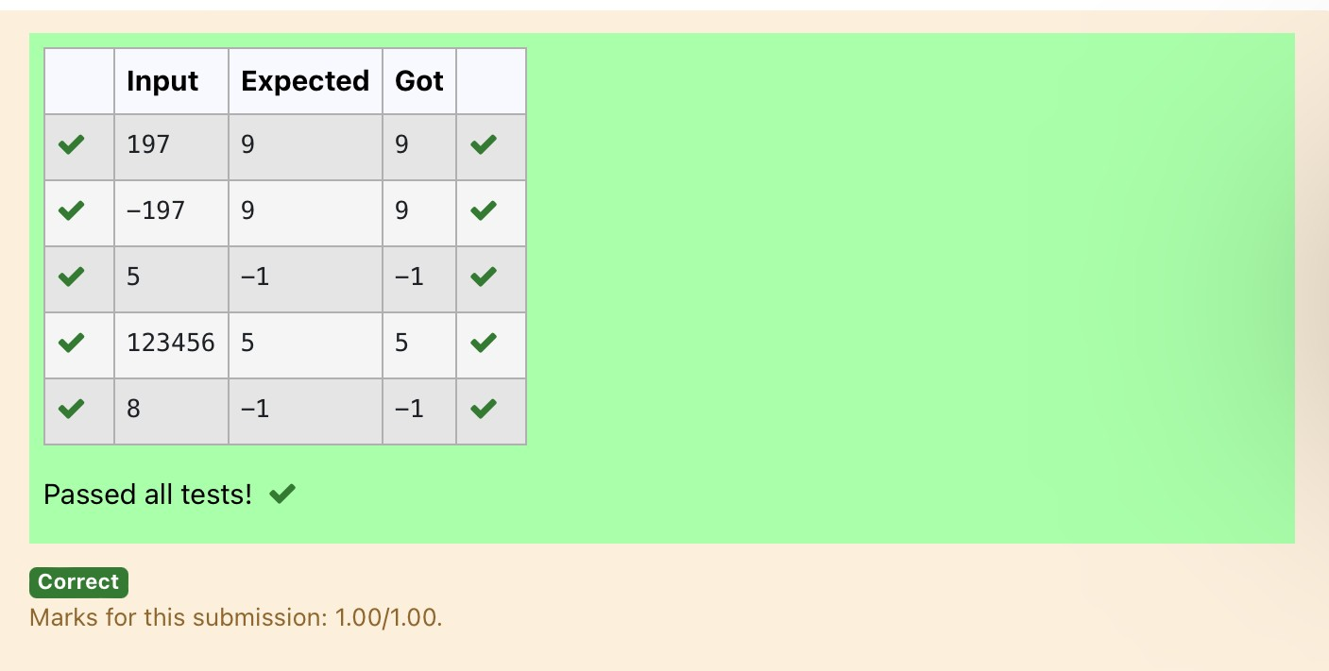

**Ex.No. : 3.10 Date:**

**RegisterNo.: Name:**

## ChineseZodiac

TheChinesezodiac assigns animals to years in a 12 year cycle. One 12 year cycleis showninthetablebelow.The pattern repeats from there, with 2012 beinganotheryearofthedragon,and1999beinganotheryearofthehare.

YearAnimal2000Dragon

2001Snake

2002Horse

2003Sheep

2004Monkey

2005Rooster

2006Dog

2007Pig

2008Rat

2009Ox

2010Tiger

2011Hare

Writeaprogramthatreadsayearfromtheuserand displays the animalassociated with that year. Your program should work correctly for any year greaterthanorequaltozero,notjusttheoneslistedinthetable.

SampleInput1

2010

SampleOutput1

2010istheyearoftheTiger.SampleInput2

2020

SampleOutput2

2020isthe yearof theRat.

# Program:

a=int(input())b=a%100

c=b%12if(c==0):

print(a,"istheyearoftheDragon.")elif(c==1):

print(a,"istheyearoftheSnake.")elif(c==2):

print(a,"isthe year ofthe Horse.")elif(c==3):

print(a,"istheyearoftheSheep.")elif(c==4):

print(a,"istheyearoftheMonkey.")elif(c==5):

print(a,"istheyearoftheRooster.")elif(c==6):

print(a,"istheyearoftheDog.")elif(c==7):

print(a,"istheyearofthePig.")elif(c==8):

print(a,"istheyearoftheRat.")elif(c==9):

print(a,"istheyearoftheOx.")elif(c==10):

print(a,"istheyearoftheTiger.")

elif(c==11):

print(a,"istheyearoftheHare.")

# Output:

